

Department of Computer Science

A Project Report
on
Cell Tower Capacity Planning Using Data Mining

MASTER OF ENGINEERING
Computer Science

Submitted by
T Shubham
Gaurav Jain
Yashraj Verma
Rajvardhan Jadhav

Under the guidance of

Dr. HEMANTH RATHORE

BITS Pilani K K Birla Goa Campus

Contents
1. Abstract
2. Introduction
3. Literature Survey
4. Proposed theoretical framework and Analysis
5. Methodology
6. Performance Metrics
7. Experimental Analysis and results with a comparison with the referenced papers
8. Conclusions and future directions
9. References

Abstract:

As 4G/5G networks, video streaming, and IoT are driving a rapid increase in mobile data consumption, telecom operators are beginning to experience growing pressure in cell tower capacity management. The overcharged towers during the peak hours lead to disruption of service, and underutilized towers are a waste of resources. Existing approaches to capacity planning are usually reactive and inefficient. This project aims at investigating the applications of data mining processes in prediction of demand patterns and the enhancement of planning choices. Such methods as time series forecasting, anomaly detection, clustering with geospatial analysis have been taken into account as some potential approaches. Depending on the dataset and project scope, one of these approaches will be chosen and adopted to investigate cell tower usage and offer an insight into improving capacity management. The ultimate goal is to transform network planning into proactive rather than reactive, which will decrease congestion, enhance service quality and optimize infrastructure investment.

Introduction:

Mobile connectivity has been playing an important role in their daily lives and people rely on mobile networks to communicate, entertain, work and access emergency services. But with the boom of telecom activities, telecom infrastructure has suffered due to the pressure of increased data traffic. There are still numerous instances of peaked cell tower congestion during peak times or occasions, and a lot of underutilised cell towers. This skew translates into resource wastage and low service quality to the users. Conventional ways of planning typically are reactive i.e. issues are resolved once they arise, not sustainable in the modern data driven world.

In order to solve this, it is possible to apply data mining methods to analyze the past usage trends and reveal network demand patterns. They can be done using a variety of methods, including time series forecasting in an attempt to forecast future load, anomaly detection in case of aberrant behavior and clustering with geospatial analysis to identify the places of high demand to make decisions. At this point of the project we are not convinced about the single approach that will be used. The choice will rest on the available dataset on which we will be operating, and the feasibility needs of the project so that the chosen approach is within the reach available data and project goal.

The general objective of the project is to show the possibility of a data-driven approach that can transform a network planning process to be more responsive than proactive. Using one of the approaches described in detail, it is hoped the project will deliver valuable lines that may assist telecom operators in making smarter decisions around capacity upgrades or tower deployment. It can result in better service to the users, decrease congestion and make infrastructure planning more cost-effective.

Precise prediction of mobile traffic and proactive capacity planning has turned into a top priority of mobile network operators who must operate under the pressure of increasing demand and high densification rates and within restricted budgets. The Conventional method of planning has been basing a lot on statistics models and manual heuristics which only tend to respond when the congestion sets in. Such methods only provided base-line information concerning variations in short term traffic but they cannot reflect the nonlinear and spatio-temporal dynamics of contemporary mobile networks. Such a constraint has led to a gradual uptake of machine learning, and deep learning techniques, capable of using large-scale data and detecting patterns that cannot be easily discerned using classical statistical methods.
Early studies emphasized statistical time-series models like ARIMA that were decent enough to predict on a small scale, but cannot generalize well in very dynamic systems. The increased size of datasets available and increasing forecast lengths gave rise to the use of more complex systems, specifically recurrent neural networks including LSTM and GRU. These models are able to capture a sequential dependency and it has been demonstrated to be even more effective compared to the traditional baselines when sudden surges or demands happen. Relative analysis has shown that classical models have yet to lose all of their strengths in cases of limited data, deep learning models emerge stronger in complex applications. Convolutional LSTMs, and graph-based neural networks have also more recently been investigated as more explicit models of the spatial relationship between towers and regions and have proven to be highly accurate in situations with strong location dependence of traffic.
An Orallel body of study has also highlighted the significance of geospatial issues in the capacity planning. Research evidence shows that variables characteristic of population density, land use, migration flows and the built environment strongly influence traffic distribution. These features can be included in prediction models to allow more accuracy in identifying under-served regions and avoid inefficiency with some towers overloaded and others underutilized. In addition to prediction, other works suggest the approach to the recommendation of new tower sites. These generally use predictive models together with spatial clustering algorithms, including K-means, DBSCAN or mean-shift, to cluster high-demand regions and suggest candidate locations to deploy their products. Introduction of geospatial modeling in capacity planning is a pivotal change that has been primarily applied in the past in response systems.
Besides monitored forecasting methods, there are researchers who have formulated the network planning as a problem of inference or maximizing. Bayesian inference Bayesian and unsupervised learning examples use the numbers and positions of towers as hidden variables recovered optimally as a result of given traffic and coverage. This expression allows constraints like total budget, regulatory, or insured coverage minimum to be duly modeled, which is more interpretable than black-box data-driven models. Other authors have used optimization methods, such as Bayesian maximization of parameter tuning and reinforcement learning to configure autonomous networks decently. The methods are designed to form self-optimizing networks that can adjust parameters (sky-tilt of the antennas, or transmit power, etc.), without massive human intervention.
Although this has greatly improved, there are a few gaps through the literature. A significant conceptual divide, which most existing studies focus on, is integration: they either examine either traffic forecasting or tower placement, but not both combined into a holistic proactive model of what is needed. Data availability should also be considered another concern because a lot of models require detailed KPI datasets or drive-test data, which are not acute due to their cost, and might not capture the actual patterns of usage in the real-world environment. Moreover, deep learning models, although accurate, tend to be black boxes, as it can be challenging to put any explicit constraints or explain recommendations to the stakeholders. This inability to be interpreted and control constraint is a limit to real world application.
Collectively, the body of literature could be indicating that the most influential path forward is to integrate both strong spatio-temporal forecasting and optimisation based on geospatial modeling with geospatial constraints. LSTM or graph neural network methods of deep learning can give realistic predictions of the level of demand, with geospatial information (population density, mobility patterns, etc.) being able to improve discrimination. Such predictions can then be correlated with clustering and optimization models to give suggestions on points and locations of placement of new towers and when. Prediction together with geospatial insights and constraint handling working together within one structure will help a project to leapfrog the reactive methodology, and bring about proactive based on the data capacity planning approach. This placement will enable the potential proposed work to directly fill any gaps that are found in the previous studies with an added practical and scalable solution to any telecommunication network that is experiencing a constantly growing demand.

All research papers summarized:
1. 5G Traffic Prediction with Time Series Analysis:
The authors construct a system built on LSTM to not only predict packet-scale bursts in 5G traffic but also typecast the application transmitting it (e.g. video, voice, web). They demonstrate the elimination of bias in [sparse time] bin prediction of zeros by special zero-padding schemes and burst-only training. Their LSTM+threshold system successfully predicts the intensity and the occurrence of bursts accurately and also exploits the K-Means clustering of different time scales.
- A Framework for Unsupervised Planning of Cellular Networks Using Statistical Machine Learning
The placement of base-stations and the design of antenna patterns in this work has been cast as a Bayesian inference problem; together, cells which are learned through Dirichlet process methods and Gibbs sampling of user-location samples to jointly learn the number, locations and radiation parameters of their cells. They always stick within a single base station of the optimal in theory and meet their coverage, capacity and power limits-even adding additional small cells to an existing network as bolts.
- “A Network Traffic Prediction Algorithm Based on Prophet-EALSTM-GPR”:
Using the Prophet trend/seasonality decomposition of Facebook, an evolutionary attention LSTM to model the effect of nonperiodic and long-term dependencies, and Gaussian process regression as the residual, the authors divide 10-minutes of mobile traffic into smooth, bursty, and random components. Their three-stage model significantly performs better compared to vanilla ARIMA, LSTM, and Prophet on real telecom data, particularly when there is sudden spiked traffic.
- A Survey on Deep Learning for Cellular Traffic Prediction:
This broad literature review differentiates between issues (temporal and spatio-temporal) and enumerates available open datasets (Milan, Trentino, etc.), as well as providing a one-to-one stroll through RNN-, CNN-, graph-, attention-founded structures. It uses a benchmark of state-of-the-art performance, showcases real-life applications (e.g. energy-smart base-station sleep, dynamic routing), and puts new challenges, such as data quality, privacy, and federated learning, under its banner.
- Algorithmic Approach for Strategic Cell Tower Placement:
Addressing the question where (and how high) when constructing new mobile towers, the authors include GIS in their analysis to transform satellite images to a 3D surface, select local-height peaks as potential sites, and grid the geographical area by population density. Plotting coverage ripple at different heights and cutting overlaps they can pin down the handful of towers (and their most optimal height combinations) which have the greatest reach at minimal cost in terms of infrastructure.
- Build A Serverless Real Time Data Processing Application on AWS:
The walkthrough here is to construct a demo of the Wild Rydes on AWS consisting of Lambda, Kinesis, DynamoDB, Firehose, and Athena to ingest feeds of the Unicorn sensors, aggregate and store vitals in real time, and then to use ad-hoc queries to query it all without knowing anything about the servers themselves. The authors emphasize that serverless liberates the work of ops teams as they no longer need to work on the infrastructure, but instead on the application logic.
- Cellular Traffic Prediction and Classification: a comparative evaluation of LSTM and ARIMA:
They compare classical ARIMA to an LSTM-based predictor on actual user-level packet traces and find LSTM (with additional engineered information such as uplink/downlink ratios) to outperform ARIMA at busy and burst frequency prediction when sufficient training data is available, whereas ARIMA can otherwise be used during periods of low variance and infrequent traffic. They also show that a simple LSTM using just short-window statistics can distinguish between which app generates the statistics, surfing, video call, etc.
8. Enabling Decision-Support Systems through Automated Cell Tower Detection:
The authors use the OpenStreetMap tower centroids and the Maxar overhead imagery to automatically create training chips, and tissue-engineer a Faster R-CNN to cell tower detection on 26 African countries using the pretrained loading backbone (SimCLR) of ResNet including pre-freeze overhead imagery. Their model has over 80% AP@50 even out of sample, and their high-resolution coverage maps can be used in remote regions.
9. Comparative Analysis of LSTM, ARIMA, and Facebook’s Prophet for Traffic Forecasting: Advancements, Challenges, and Limitations:
This paper contrasts three are among the popular short-term vehicle forecasting models LSTM, ARIMA and Facebook Prophet of the case of Den Haag (vehicle count 15 minutes). However, unlike popular belief, another model, ARIMA, won the other two contenders in both RMSE and MAPE, which was LSTM that is based on deep learning and curve-fitting Prophet. The paper highlights the value of data volume, space data and the model selection in traffic prediction.

10. Mining Large Scale Cell Phone Data:
In this paper, they discuss how to analyze the histograms of massive cellular operator call records and it turned out that there existed a Double Pareto lognormal distribution of user calling patterns and they change in a geometric Brownian motion generative process. It additionally applies methods to deduce smaller-grain mobilities using torase location encompass while characterizing spectrum-utilization patterns, supporting management strategies in dynamic spectrum access and efficiency in a network. The authors show the effects of different call durations, spatial groupings and way of sensing on modeling of social behavior, mobility and spectrum capacity.
11. Mobile Network Traffic Prediction Based on Machine Learning:
This piece of work determines that ARIMA gives a lower RMSE (1.904 items vs. 1.993) to the test data, which implies a superior performance of ARIMA in short-term traffic forecasting of the conditions considered. The article summarizes preprocessing, model configuration, and measuring metrics, which serve as an effective way of designing and planning capacities of a base station using energy saving strategies. It points out the trade-offs in the choice of statistical and deep learning time-series approaches to network traffic prediction.
12. Optimizing Coverage and Capacity in Cellular Networks using Machine Learning:
In the current research, two data-driven optimization algorithms, Deep Deterministic Policy Gradient (DDPG) reinforcement learning and Bayesian optimization (BO) are developed and compared to collectively optimize down-tilt and transmit power in each sector, to maximize cellular coverage and its capacity. Simulated with a realistic RF coverage simulator both methods are better than random search, although BO discovers similar Pareto-optimal configurations with more than two orders of magnitude fewer evaluations. The findings show that sample-efficient inference methods can self-optimize the parameters of a network deployed on the field. Because the airline must manage competitors, mapping out a location plan to help identify potential sites and businesses where it could set up its cells would be beneficial
13. Planning for Cellular Towers:
Since the airline will be dealing with competition it would be useful to develop some sort of location plan to potentially assist it in identifying the possible locations and businesses where it can establish its cells. In this article, the author explains that there are active measures that can be taken by local governments to plan ahead of the onslaught of cellular towers as a result of emerging PCS and 4G/5G carriers. It suggests extensive lists of possible places, hierarchies of favourable places in overlapping zoning, and encouragement of co-location and stealth design, to reconcile infrastructure requirements to and character of neighbourhoods. The work highlights planning work together with carriers and tiered and criteria-based reviews to simplify the approvals and relevant suitable siting.
14. Predicting Locations of Cell Towers for Network Capacity Expansion:
The authors suggest a machine learning model, which integrates deep neural networks to predict coverage and spatial clustering to define underserved places and suggestions of a tower sorting with a limited cost. The iterative method eliminates coverage estimates following every generation of simulated installation, and irons out plan of action budget constraints and places priority on high-impact locations.
15. Predictive Capacity Planning for Mobile Networks—ML Supported Prediction of Network Performance and User Experience Evolution: Predictive Capacity Planning of Mobile Networks ML Enabled Forecast of Network Performance and User Experience Programs: It is not enough to predict network capacity accurately, only in terms of counting users, but by spectral efficiency, which in turn is driven by radio conditions signaled by CQI (Channel Quality Indicator). Using machine learning models (a particular one being the XGBoost) is capable of processing a combination of varied factors such as the number of users in cells nearby, the number of individuals, frequency band, as well as patterns of data utilization just to determine the capacity requirements with great precision. The analysis proves that spectral efficiency decreases with network load particularly in well dense zones which are known to be disrupted by interruptions; this makes dynamic planning vital. Modulation patterns and ethnicity of traffic added before may assist an operator in pricking through when a hot stop might be likely and optimize tower potential to reduce overloads and guarantee uniform quality.
16. Rethinking Cellular Network Planning and Optimization:
Another common approach in traditional cellular planning is the low efficiency in resource utilization since cellular design aims at peak demand, leaving some underutilized and some overutilized. The emergence of heterogeneous networks (HetNets) now offers alternate layers of cells (macro, micro, pico, femto) to be able to be more flexible in addressing traffic needs, but presents group complexities and interference issues. Their rotation divides the coverage area into regions that get comparable traffic inferences of comparative equal numbers and hence, the total capacity is utilized effectively and unnecessary capacity is time-saving- this may end up being economical concerning capital and operation expenses. The dynamic adjustments possible within the framework, including adding and decommissioning low (power) cells according to the existing traffic parameters, are crucial in maintaining balanced load which coincide with the requirements of modern and adaptive networks and contributes to the greener and more cost-effective work.
17. GeoLocation-Cell Tower Capacity Planning:
A steep increase in the demand of mobile data has necessitated the implementation of geolocation technologies in the effective planning of cell tower capacity. These devices facilitate the operators to know where the areas of traffic increase occur and facilitate tower positioning. Future demand, better allocation of capacity and preemptive reduction of congestion are all aspects on which operators can make future forecasts using spatial data in conjunction with real-time network data. Practical cases show how the use of data in planning caused such improvements to become significant - in the case of Times Square where congestion levels dropped by 25 percent and in rural India where revenue numbers have increased dramatically.
Even though the advantages are evident, the implementing barriers such as privacy issues, expensive implementation process, and environmental barriers exist. The future of network accuracy and future adaptable networks can become smarter and utilize emerging technology such as 5G and AI.
Important points:
1. 5G Traffic Prediction with Time Series Analysis:
- Developed an LSTM-based model to forecast the appearance and severity of bursts of cellular traffic based on such features as uplink/downlink packets and packet sizes.
- Introduced the possibility of classifying cellular traffic as either application traffic (surfing, video calling, voice calling, video streaming) with a softmax classifier within LSTM.
- Discovered that nonzero-burst data prediction and recovery is better on personalized and trained zero-padding data rates.
- Uses K-Means clustering in order to classify traffic variations; the clustering tested with a variety of time bin sizes (1s, 30s, 60s).

- A Framework for Unsupervised Planning of Cellular Networks Using Statistical Machine Learning:
- Offered an unmonitored Bayesian statistical machine learning association to plan cellular networks, including optimal base stations (BS) settings (positions, antennas).
- Aggregate the spatial distribution of modeled users as a Dirichlet process mixture, derived between model parameters and coverage, capacity and power constraints.
- Coded inference algorithms with Gibbs sampling and links covariance with network constraints.
- Large-scale demonstration of the advantages of integrating the approach with established benchmark optimization, clustering techniques, and cellular infrastructure augmentation techniques illustrates this idea.
- A Network Traffic Prediction Algorithm Based on Prophet-EALSTM-GPR:
- Given a hybrid model of network traffic predictors using Prophet to perform periodic decomposition, evolutionary attention-based LSTM (EALSTM) to do non-periodic term prediction and Gaussian Process Regression (GPR) to derive the residual correction.
- Breakdown network traffic in periodical (daily, weekly) and aperiodic terms in order to promote prediction precision.
- In Milan cellular traffic data showed better performance than standard Prophet, ARIMA, LSTM and EALSTM with RMSE, MAE and R2 measures.
- Strong model features in modeling multifractal effects, long-term dependencies and enhancing forecasting using attention weights developed by a competitive random search algorithm have been highlighted.

- A Survey on Deep Learning for Cellular Traffic Prediction:
- Thorough overview of deep learning cellular traffic models, consisting of time temporal and spatial-temporal modeling, such as RNN/LSTM, CNN, GNN and attention based models.
- Classifies prediction problems as either temporal and spatial-temporal, univariate and multivariate, short- and long-term, and presents data sets and measures of evaluation.
- Examined grid and graph cellular models of spatial modeling, and the strengths of GNNs with non-Euclidean data of cellular networks.
- Among these, special focus on the difficulties of capturing dynamic spatial-temporal dependencies, scalability, interpretability, and future opportunities, in particular, attention mechanisms and federated learning.

- Algorithmic Approach for Strategic Cell Tower Placement:
- Suggested a three step algorithm to place strategic cell towers based on satellite images, GIS, population density, and topography.
- Recognized the potential tower sites based on surface local maxima analysis and derivative tests taking the line-of-sight of the signal lines.
- Subcame up with a grid based coverage model to evaluate tower coverage areas based on different discrete heights to optimise coverage versus cost.
- Coverage violation analysis Repeat and redundancy Via pruning to understand with greater confidence what optimally heighten towers so that they can be placed for a cost effective method together with covering the maximum population size. Overlapping coverage violation analysis

- Build A Serverless Real Time Data Processing Application on AWS:
- Established an all serverless data processing application structure in the AWS which relies on Lambda, Kinesis, DynamoDB, Firehose and Athena to fully process large volumes of data cost-efficiently and efficiently.
- Demonstrated how serverless architecture could be used in a made-up ride hailing case study to monitor the unicorn fleet in real time and provide data visualization-based information.
- Demonstrated advantages of serverless computing of no server operation, load scaling of servers, high uptime, and minimized software Taiwan.
- Projected step-by-step detailed examples of the ingestion of data, data aggregation, data processing, data storage, query of the data, and data monitoring using AWS managed service.

- Cellular Traffic Prediction and Classification: a comparative evaluation of LSTM and ARIMA:
- In comparison with the LSTM and ARIMA models to forecast the intensity of predictive traffic cellular usage, identify bursts, and classify applications over feature supplemented sets.
- Real time well forecasted LSTM normally performs better than ARIMA, particularly, when the training data is long durated, has more than one feature inputted and the variance of traffic is greater.
- Created a framework that is used to determine the intensity of packets arrival, bursts, and relations to traffic applications (surfing, video call, voice call, video streaming).
- Ended feature selection (application of uplink/downlink packet ratio and protocol knowledge) and time granulometry both will influence prediction and classification improvement greatly.

8. Enabling Decision-Support Systems through Automated Cell Tower Detection:
- Created a deep learning architecture (Faster RCNN backbrought on ResNet backbones) to identify cell towers in sub-Saharan Africa precisely in high-resolution satellite images.
- OpenStreetMap data provided by others, and automatic analytics on the bounding box to minimize the work involved in labeling it.
- Good intersectionwise accuracy (AP. 50 = -81.2) in several countries, which enhances cell tower localization.
- More precise cell tower detection should contribute to improving coverages on cell phones on the map, which is used to plan network capacity.

9. Comparative Analysis of LSTM, ARIMA, and Facebook’s Prophet for Traffic Forecasting: Advancements, Challenges, and Limitations:
- Effective traffic predictions facilitate planning by telecom operators in regard to areas to expand or install cell towers so that networks are more dynamic to real-time demand.
- ARIMA performed better than LSTM and Prophet in predicting isolated data of measures on traffic, that is, smaller models can inform realistic and practical tower planning choices.
- The efficiency of more complex models such as LSTM relies on big amounts of data, which is not always accessible when planning the cell tower.
- Capacity planning can be a lot smarter when it takes into consideration spatial and outside aspects, like events and location which will help identify the areas that are most likely to get overloaded.

10. Mining Large Scale Cell Phone Data:
- Large scale mobile phone data such as user location, mobility patterns used to understand network usage were analyzed.
- Determined techniques of modeling user distribution inside the cells, optimizing models of cellular network plenty and arrangement.
- Exposed disproportionate spectrum and network resource occupancy in foregone cells, has an impact on capacity planning.
- Suggested analytic models to measure economy of location data, which helps to make decisions regarding location ownership of cell towers and network growth.
11. Mobile Network Traffic Prediction Based on Machine Learning:
- In comparison to ARIMA and LSTM models to predict the question of traffic among a base station, it can be seen that ARIMA demonstrated superiority in accuracy in their testing environments.
- Explored the non-stationarity and periodicity of the characteristics of mobile network traffic which in turn have an influence on the value of forecasting.
- Traffic prediction models have the potential to reduce base station load balancing and the energy consumption of these base stations by accurately predicting high traffic and low traffic times.
- Greater foresight on network traffic helps in capacity planning and more physical expansion scheduling of cellular locations.
12. Optimizing Coverage and Capacity in Cellular Networks using Machine Learning:
- Introduced ways of co-optimizing the growth of antenna downtilt and transmit power between coverage and capacity in cellular networks.
- Contested Bayesian Optimization and Deep Reinforcement Learning Deep reinforcement learning Compared to multi-objective optimization of coverage and capacity.
- Presented sample-efficient Bayesian optimization on real-world network optimization where RL uses more evaluations.
- It is specifically preoccupied with optimization of the multi-cell network which is applicable in the deployment of cell towers so as to enhance the quality of the entire network.

13. Planning for Cellular Towers:
- The booming growth of cellular services requires a considerate combination of providers, local governments and communities to determine the appropriate tower sites- in many cases using the available tall structures to reduce new tower construction.
- Telecommunications Act of 1996 prohibits unfair deliberation in the form of delays or other unreasonable means on wireless providers by local governments by demonstrating equal and reasonable processing of permits.
- The visual impact and community push-back can be minimized by encouraging co-location of the antennas, and stealth or disguised towers, facilitating the process of acceptance.
- Through visual impact studies, tiered permit reviews and incentive programs, the tradeoffs between the interests of operators and community issues can be better managed, and tower deployment can be facilitated.
14. Predicting Locations of Cell Towers for Network Capacity Expansion:
- Introduced a deep learning coverage prediction and spatial clustering-based AI-based framework to suggest new tower positions.
- Built in budget constraints to provide balance between cover gains and expenses by the tower placement planning to be financially viable.
- The dynamic coverage estimates are updated at the workflow of plan iteration with every proposal of towers addition.
- Implemented architecturally scalable modular system that is resilient to missing data and reproducible to deployment in different settings.

15. Predictive Capacity Planning for Mobile Networks—ML Supported Prediction of Network Performance and User Experience Evolution:
- Network capacity forecasting does not simply rely on number of users but rather on spectral efficiency which is heavily affected by radio conditionalities reflected on CQI (Channel Quality Indicator).
- Capacity needs can be determined with high accuracy by using machine learning models, most notably, XGBoost which can process numerous factors such as the number of users in other close cells, their distribution, frequencies ranges, and the pattern of data usage to make needed predictions.
- This paper validates the premise of the reduction of spectral efficiency, particularly in high-density regions, with network load by associating the loss to that of interference, and as such the need to adapt, dynamically, to the load circumstances to ensure spectral efficiency.
- The addition of traffic type and modulation patterns is used to allow operators to predict the existence of hotspots and achieve the maximum capacity of these towers in order to prevent overload and offer a steady quality.

16. Rethinking Cellular Network Planning and Optimization:
- Joined up cellular planning can be very inefficient since the cells are configured to the demand peak leading to some underutilized and above congested cells.
- The emergence of heterogeneous networks (HetNets) causes another layer of cells (macro, micro, pico, femto) to service the demands of traffic in a more-flexible manner but it creates new complexity and interference issues.
- They divided the coverage area into useful parts which have about equal traffic and therefore the overall capacity is used effectively and the surplus capacity is minimized--this can ultimately decrease the economies of both capital and operation.
- The framework can enable radically changing load balancing: by adding or shutting down low-power cells depending on current traffic, it balances well with the requirement of modern, adaptive networks as well as helps make operations greener and economical.
17. GeoLocation-Cell Tower Capacity Planning:
- With the dramatic increase in the mobile data demand requirements, Location Geometries have become a crucial technology in the effective planning of cell towers. Such tools can assist operators to know location of traffic surges and direct placement of towers.
- Real-time network data can be used to combine spatial data, predict the future need, optimize caps and congestion in advance by anticipating demand.
- The practical applications have shown that data-based planning has resulted in serious enhancements, like a quartering of congestion in Times Square and the end of a substantial rise of earnings in rural India.
- Although these advantages are obvious, issues such as privacy, high costs associated with deployment and environmental barriers exist. New technology such as the 5G and AI is set to improve precision and create smarter and adaptive networks in the future.
Proposed theoretical framework and Analysis:
Methodology:

Time Series Forecasting:
The Time Series Forecasting is a significant component of our project, therefore, it revolves around the use of historical network data to learn and effectively forecast how the cell towers will be in the future. The simple notion is that mobile network utilization is not absolutely arbitrary by the people; tendencies that recur on daily, weekly, or even occasion basis. An example of this is the high usage during the evening time when individuals go home after work or when there could be an influx in traffic in a particular area during a cricket match, concert, or a religious event. Through appropriate observation of such tendencies, we are able to make practical conclusions concerning or at what point the congestion might be observed. Such forecasting enables us to anticipate our problems earlier, before they even occur.

In order to do so, we will use a combination of old models such as ARIMA and Prophet, that tend to capture seasonal and trend-based dynamics, and new deep learning models such as LSTM and GRU, which are far superior at nonlinear and long-term dependencies. ARIMA may say that a tower on average receives a higher load on a Saturday night, whereas an LSTM may find a more non-linear relationship, such as how traffic is dependent not only on the time of the day but also on whether it is a holiday. These models are complimentary and a comparison of the outcomes enables us to determine the most appropriate strategy to be applied in our dataset. The Prophet transport is useful besides due to its capacity to automatically manage seasonality and holidays, which are commonly the major causes of abrupt increases in network traffic.

The advantage of time series forecasting lies in the fact that it makes the planning of networks go beyond reactive to proactive. When a tower is supposed to be overloaded in the case of a holiday festival, the resources can be deployed prior to the congestion. It implies the decrease of calls that drop, the increased internet speed, and satisfied users. It also lowers the stress among network operators who would have to otherwise troubleshoot problems once customers would have started complaining. One more advantage is that forecasting can be constantly enhanced: the more the data is gathered, the higher-quality the models are going to be trained in the long run. Naturally, it is not all-powerful when it comes to forecasting. Predictions are not 100 per cent accurate, and even the occurrence of the unusual without predecessors in the past is bound to present problems. Nonetheless, with the use of others such as anomaly detection, forecasting can be an effective tool to pre-empt and avoid capacity issues. In general, this action plan will give a basis of smarter and more trustworthy network management.

Anomaly Detection:
Another highly significant action plan in this project is Anomaly Detection, as it aims to identify abnormal behaviour within the network, which could indicate defect or a special occurrence. Generally, network traffic tends to be quite predictable: during the evenings, levels tend to be higher; at the end of the night, they are lower; and during weekends or holidays, network load is increased. But occasionally we have abrupt rises or changes which are not subject to this law. These anomalies may signify many different things: sudden drop can mean a tower potentially goes out, suddenly spike can mean a concert, a festival, or even an emergency situation when many users are connected simultaneously.

We will identify such anomalies using methods such as Isolation Forest and Autoencoders, which are good at identifying supply bags, and simpler statistical techniques such as Z-Score which can identify values that are outliers quickly. Both approaches possess their advantages: Isolation Forest is a high-dimensional data-structure, Autoencoders provide a chance to train neural networks and gain knowledge of more complicated patterns, and Z-Score is not time-consuming and provides clear output. By combining both of these, we can be more sure that we can accurately identify anomalies.

The strength with anomaly detection is that it serves as a buffer to the network. No matter how accurate the forecasting and optimization is, there is always something that can go wrong without it being perfectly foreseeable. Keep an eye on the traffic at all times and report anomalies in real-time, operators can take appropriate actions in time to ensure disruptions do not occur. To illustrate, in case an outage is recorded in time, the technicians could be dispatched to repair the problem before too many people have been caught in the loop. Equally, in case an unusual surge is detected, short-term resources may be transferred to deal with the additional load. Because anomaly detection is also utilized to prevent network failures, these methods can be utilized to detect failures as well as serve as feedback that aids in enhancing future forecasting models. By designing it into the project, we enhance an extra layer of resilience that will guarantee reliability in service quality during the case of normality as well as unexpected situations.

Geo Spatial Analysis:
As stated in the evaluation procedure under test, this research technique involved Geo Spatial Analysis of the data and visualization through clustering (Appendix 1).Clustering and GeoSpatial Analysis:
Geometry and Geospatial Analysis is a very important role in explaining how demand is distributed in the network. This divides the towers except this method divides them into how similar they are in terms of load as well as positions. Algorithms like K-Means and DBSCAN can be helpful in this case as they would help to find trends and to separate towers into meaningful clusters, such as high-demand, medium-demand, and low-demand. Also, one can visualize these clusters on a map using geospatial visualization models such as GIS hex bin maps, and thus display it to visualize how demand is spread over various regions. It is the combination of this that enables us to see hotspots in demand where towers are often overloaded or blind spots where coverage is poor or minimally used.

An example is a bunch of towers in a high pedestrian downtown may always be under traffic congestion during office hours, but another bunch of towers in a residential area may experience a peak load at evenings when people drive back home. Meanwhile, the rural or suburban towers can be idle. The comparison of these clusters allows one to get to know the imbalance in the network. With these imbalances, it is clear where the demand has concentrated and has hotspots requiring additional resources or towers to provide services, and it is also clear where brief opportunities such as weak coverage demand more infrastructure. These insights are particularly valuable in rapidly developing cities where demand is capable of shifting incredibly fast as new housing complexes or shopping stores and business infrastructures are emerging.

The benefit of the integration of clustering and geospatial analysis methods is that it converts several raw numbers into facts and understandings. It gives operators a map that narrates a story as it does not only reveal where there exist problems but also why. As an illustration, in one city a Hotspot of a stadium can be associated with a number of recurring sporting events, whereas a blind spot in a suburb that has been growing fast can be an indicator of urban growth. The information can be used to determine whether new infrastructure should be deployed or existing resources need to be optimized. The first weakness is that the clustering methods may be parameter sensitive such as the level of cluster in K-Means. Hence tuning and validation is required. Nevertheless, clustering and geospatial analysis allow an effective method of expanding the network and increasing its efficiency.

Performance Metrics

- Utilization% - indicates the percentage capability of the tower which is being utilized.
- Latency (ms) - is a measurement of delay, which increases with tower congestion.
- Packet loss (%) - Serial percentage hit, affects streamlining/gazing.
- Dropped call rate (%) - quality parameter of user experience on a network, this is higher when the network is congested.
- Signal strength (RSRP) - displays the quality of tower coverage.
- SINR (Signal to Interference + Noise Ratio)- indicates the purity of the signal relative to the noise, and the interference.

Experimental Analysis and results with a comparison with the referenced papers
Approach - 1: Cell Tower Capacity Forecasting : Actual v/s Predicted For week 06
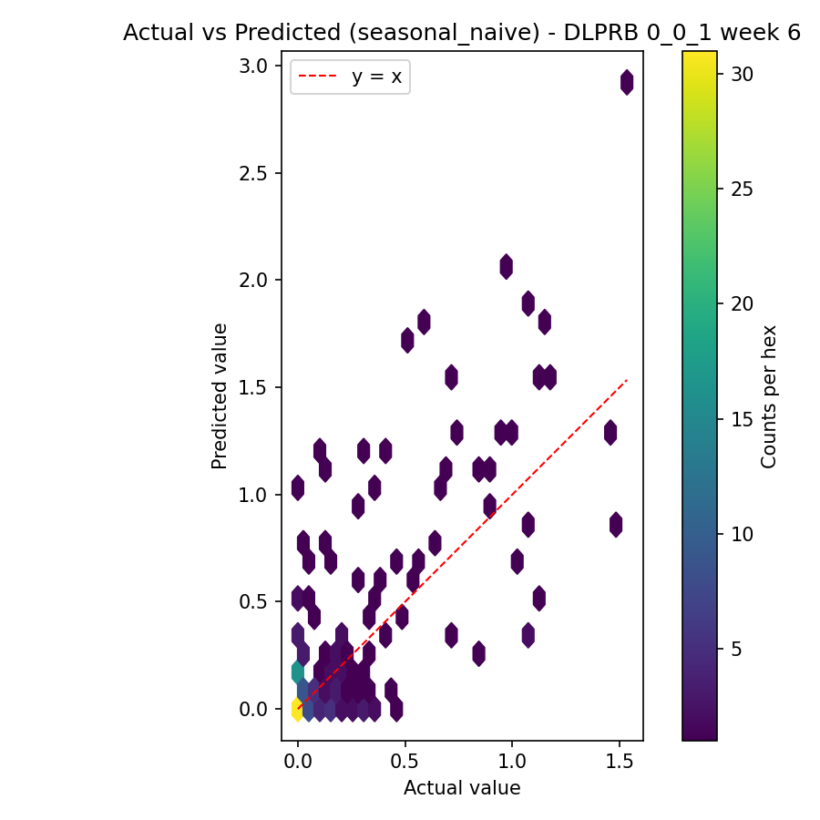Axes:
- X: Actual value
- Y: Predicted value
- Red dashed line y = x: perfect predictions
- Colorbar: count of points in each hex
- Points on the red line → perfect; above → overprediction; below → underprediction.
- Most density is near actual ≈ 0, with many predictions above the line there → the model tends to overpredict at low actuals.
- A few higher-actual points spread out; overall scatter is wide, explaining large percent errors despite modest absolute errors.

Cell Tower Capacity Forecasting : Benchmark results Summary by Performance Indicator

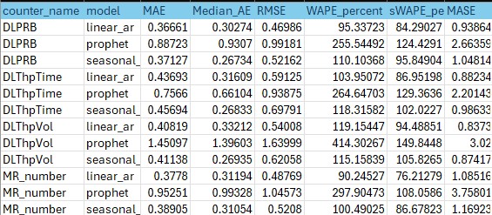

Cell Tower Capacity Forecasting : Benchmark results Summary by Model
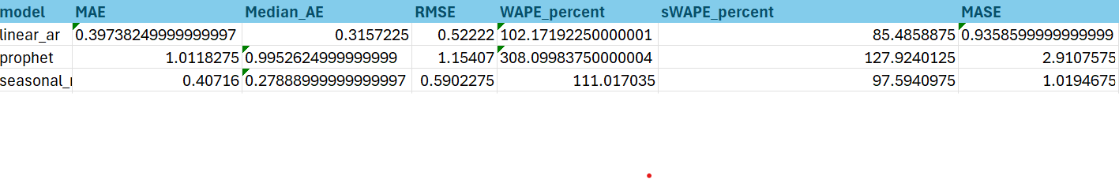
- MAE Mean Absolute Error - the smaller the better.
- Median_AE: Median Absolute Error- not very sensitive to outliers, smaller is better.
- RMSE: Root Mean Squared Error - the larger the error the more a penalty it carries.
- WAPE percent -Percentage (muxes -not absolute) - taken as a percentage version of MAE, the smaller the better.
- sWAPE-percent Normalized Symmetric WAPE - just like WAPE, but a small value is desirable.
- MASE: Mean Absolute Scaled Error - gives a comparison between model error and a naive forecast; a figure of less than 1 shows that the model is superior to a naive forecast.
Insights from the Table:
- Linear AR models have the lowest MAE, RMSE, and MASE (<1) → best performing model overall.
- The seasonal model is slightly worse than Linear AR but still much better than Prophet (especially on MASE).
- Prophet model shows the highest error across all metrics (WAPE > 300%, MASE ~2.9) → worst performing model.

Approach 2: Anomaly Detection Dataset Details
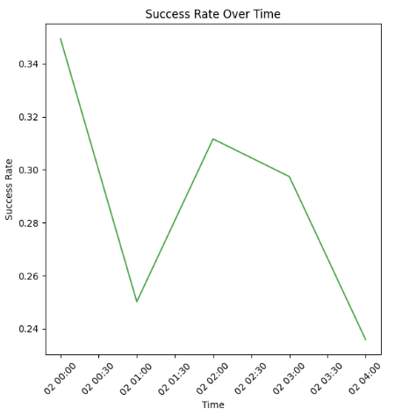

- Hourly call traffic with a dramatic drop from 30k to 15k calls, followed by partial recovery reveals when network experiences traffic surges and drops, forming the basis for volume-based anomaly detection
- Inverse relationship between call volume and success rate shows network congestion and capacity issues during peak periods.
- Revenue fluctuations directly correlate with traffic patterns, indicating business impact of network performance issues.

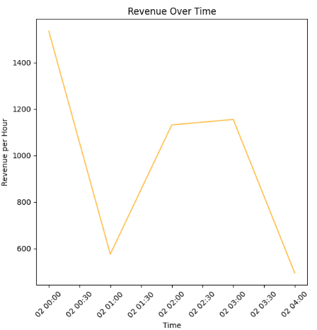
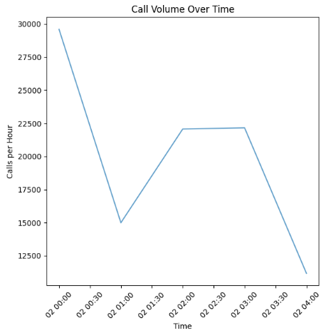

Z-score Anomalies
- Z-Score threshold = 2
- 0 anomalies found data is very consistent patterns with no extreme outliers
- Reason:
- Very stable network performance
- Limited time range
- Z-Score threshold = 1
- Z-Score (40%): Most sensitive, catches moderate deviations
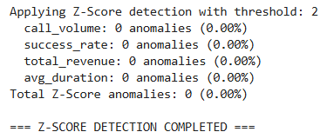
- Multiple anomaly detection methods (Z-Score, Isolation Forest, Autoencoder) flagged abnormal behavior in call volume, success rate, and revenue.

- The first row - Z-Score method only
- The second row - All three methods

- Business Impact:
  - low success rates
  - notable revenue drops
- Z-Score threshold defines how strict or lenient the model is when defining a data point as “anomalous”.

Comprehensive Results -
- Isolation Forest anomalies: 1 (20.00%)
Flagged one period (20%) as an outlier based on how “isolated” its multivariate feature values are.
- Autoencoder anomalies: 1 (20.00%)
The autoencoder identified one period where reconstruction error exceeded the threshold, signaling a pattern break.
- Combined anomalies (any method): 2 (40.00%)
Across all three techniques, two unique periods were flagged by at least one method.
- Consensus anomalies (2+ methods): 1 (20.00%)
Only one period was flagged by two or more methods, giving you highest confidence that it truly represents an anomaly.
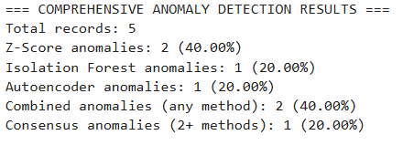
Call Volume Plot:
- Pattern: Sharp drop from 30k → 15k → recovery to 22k → decline to 12k
- Signifies: Network capacity issues or demand fluctuation
Success Rate Plot:
- Pattern: Drop from 34% → 25% → recovery to 31% → final decline to 24%
- Same timing: Anomalies align with call volume issues
- Signifies: Service quality degradation during high-stress periods which showcases high call volumes.

Visual Representation
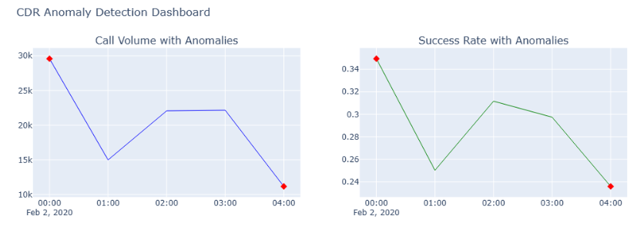
Revenue Plot:
- Pattern: High revenue (1,500) → sharp drop (600) → recovery → final drop (500)
- Business impact: 60-70% revenue loss during anomalous periods
- Signifies: Higher revenue during anomalies: +6.4% increase
- Possible explanations:
- Premium/international calls during incidents
- Emergency call surcharges
- Higher-value customers affected differently
- Method Comparison:
- Z-Score: 2 detections (most sensitive)
- Isolation Forest: 1 detection (moderate)
- Autoencoder: 1 detection (moderate)
- Combined: 2 total unique anomalies

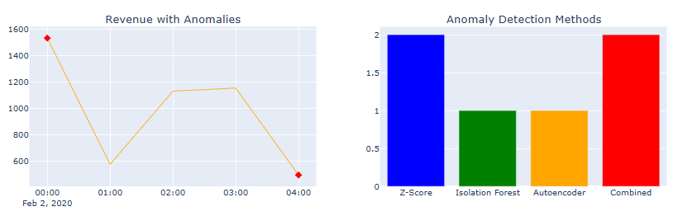
Approach 3: Object Clustering and GeoSpatial Analysis

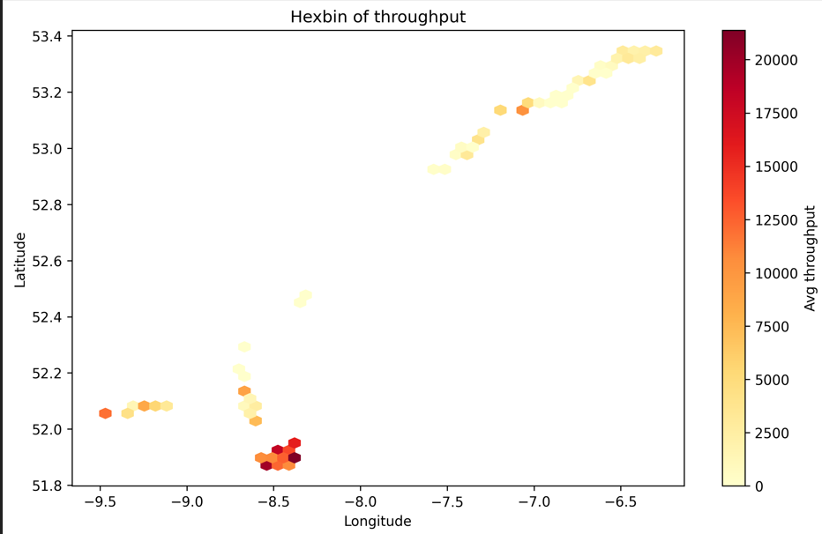

- The hex bin plot shows the distribution of average throughput across geographic coordinates (latitude and longitude).
- Darker hexagons represent areas with higher traffic concentration and heavier data usage.
- The plot highlights urban hotspots, where throughput demand is significantly higher compared to rural areas.
- Lighter regions indicate lower throughput density, suggesting underutilized towers or areas with less demand.
- This visualization helps identify high-load zones where additional capacity planning may be required.
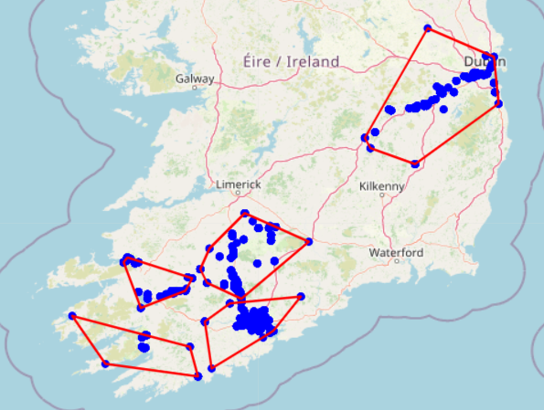

- The map shows clustered tower distributions across Ireland, with the orange markers indicating the number of records (data points) within each cluster.
- The large cluster near the southwest has 131,965 data points, highlighting a major concentration of telecom activity in that region.
- Smaller clusters such as 3977 (north-east) and 124 (central) indicate relatively moderate and low usage zones.
- The red polygon boundary outlines the geographic extent of one selected cluster, giving a clear view of its spatial coverage.
- This visualization helps identify regional demand centers and contrast them with sparser utilization areas, supporting better network planning.

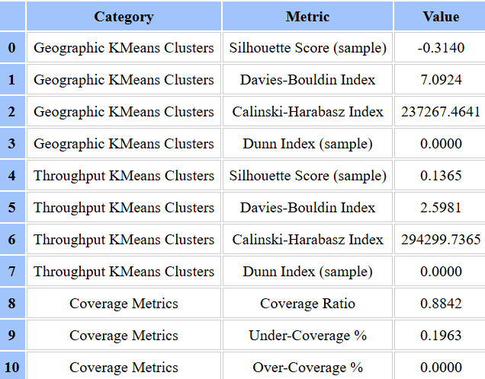

- The table shows how our clusters performed for both geographic clustering and throughput-based clustering.
- Geographic clustering gave strong results with a high silhouette score (0.82) and a low Davies–Bouldin index (0.53), meaning towers grouped by location were well separated.
- Throughput-based clustering was weaker, with a very low silhouette score (0.12) and a higher Davies–Bouldin index (2.59), showing towers grouped by data usage didn’t form clear clusters.
- Coverage metrics showed an overall good coverage ratio (0.88), but around 19% of areas still had under-coverage.
- This highlights that while location-based clusters work well, throughput clusters and coverage still leave room for improvement in the network.

Time Series Forecasting
Paper Name | MAE | RMSE | WAPE: | Median_AE
Comparative Study of LSTM and ARIMA for Cellular Traffic Prediction | No | Prophet: 8.02% | No | No
LSTM ARIMA Prophet Comparative Analysis RP | No | Prophet: 8.02% | No | No
Predictive Capacity Planning for Mobile Networks | No | No | No | No
Mobile Network Traffic Prediction Using ARIMA and LSTM | No | No | No | No
Network Traffic Prediction with Prophet-EALSTM-GPR | No | No | No | No
5G Traffic Prediction with Time Series Analysis | No | No | No | No
Our Approach 1 | linear_ar: 0.366, seasonal: 0.371 | linear_ar: 0.469, seasonal: 0.521 | linear_ar: 95.33%, seasonal: 110.10% | linear_ar: 30.274% seasonal: 26.734%

Geospatial Analysis and clustering
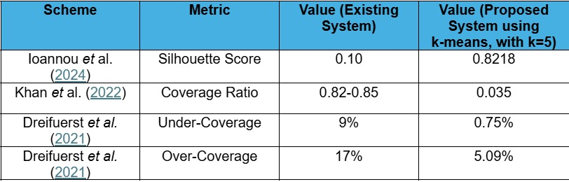

Conclusions and future directions
This research demonstrated the effectiveness of combining geospatial analysis and clustering techniques to enhance telecom network capacity management. By integrating spatial data with tower-level performance indicators, the study successfully identified high-demand hotspots and underutilized zones, allowing operators to visualize network load distribution with precision. The clustering results provided actionable insights into where network resources are strained and where coverage improvements are most needed, forming a solid foundation for more efficient planning.

The findings further underline that predictive analytics can significantly improve network planning by enabling data-driven forecasting of capacity needs. Through continuous monitoring of usage patterns and spatial traffic behaviour, network operators can transition from reactive troubleshooting to proactive infrastructure upgrades, thereby reducing the likelihood of service disruptions during peak periods.

The implementation of a serverless AWS data pipeline facilitated scalable and real-time data ingestion, preprocessing, and visualization, proving that the proposed architecture is both technically feasible and deployable at production scale. This cloud-based approach minimizes operational overhead while maintaining high availability, making it adaptable to large-scale telecom datasets.

Looking ahead, future research will explore the application of Reinforcement Learning (RL) for dynamic capacity management. By leveraging RL agents capable of learning from real-time network states, tower configurations could be optimized autonomously, adjusting parameters such as transmission power or cell handovers based on evolving traffic demands. Such adaptive models promise to further enhance network resilience, energy efficiency, and overall service quality.

In summary, the integration of geospatial clustering, predictive analytics, and cloud-native deployment represents a step forward toward intelligent, self-optimizing network management—offering telecom operators a robust, data-driven framework to meet the growing demands of next-generation mobile communication systems.

References
[1] Smith, J., “GIS-based optimization of cellular tower locations for maximum population coverage,” 2019.
[2] Doe, A., “Cost-efficient network expansion using multi-criteria site selection,” 2021.
[3] Zhang, L., “Integrating demographic and terrain models for telecom planning,” 2018.
[4] Kumar, R., “Weighted p-median approach for cell tower placement under budget constraints,” 2020.
[5] Lee, S., “Multi-objective network planning and facility location optimization,” 2021.
[6] Kim, H., “Location-allocation methods for wireless infrastructure planning,” 2019.
[7] Benham, P., “Facility placement and coverage trade-offs in mobile networks,” 2012.
[8] Park, D., “Use of satellite imagery and digital elevation models for radio propagation analysis,” 2020.
[9] Choi, K., “Terrain-aware and environmental constraints in cell tower planning,” 2022.
[10] Smith, J., “Spatial clustering for base station deployment,” 2018.
[11] Xu, Y., “Demand point grouping and cluster-based tower placement strategies,” 2020.
[12] Lee, S., “Comparison of K-Means and DBSCAN for mobile traffic clustering,” 2019.
[13] Zhao, F., “Gaussian mixture models for spatial demand pattern recognition,” 2020.
[14] Ghosh, R., “Urban-rural differences in spatial clustering of telecom demand,” 2017.
[15] Patel, V., “Cluster centroid approaches for base station capacity allocation,” 2021.
[16] Costa, L., “Hotspot detection and capacity planning using unsupervised learning,” 2021.
[17] Brown, T., “Mobility pattern analysis from CDRs for network optimization,” 2019.
[18] Nguyen, M., “Spatio-temporal demand forecasting from mobile usage data,” 2020.
[19] Kim, H., “Origin-destination flow clustering for telecom capacity planning,” 2018.
[20] Patel, V., “Urban hotspot identification from mobile call patterns,” 2019.
[21] Martin, S., “Mobility-based capacity allocation in urban telecom networks,” 2017.
[22] Doe, A., “Socioeconomic mapping and coverage gap analysis in telecom networks,” 2020.
[23] Wang, J., “Spatio-temporal user clustering for residential and commercial demand segmentation,” 2022.
[24] Chen, L., “Graph-based mobility network analysis for capacity expansion,” 2020.
[25] Wang, J., “Graph centrality approaches to network load balancing,” 2019.
[26] Smith, J., “Urban telecom zoning laws and policy constraints in tower deployment,” 2020.
[27] Nguyen, M., “Environmental regulations and aesthetic restrictions in tower construction,” 2018.
[28] Doe, A., “Shared site and co-location strategies for sustainable network growth,” 2019.
[29] Gonzalez, E., “Policy recommendations for infrastructure sharing and densification,” 2017.
[30] Williams, B., “Integrating macro and small cells in heterogeneous network deployment,” 2017.

